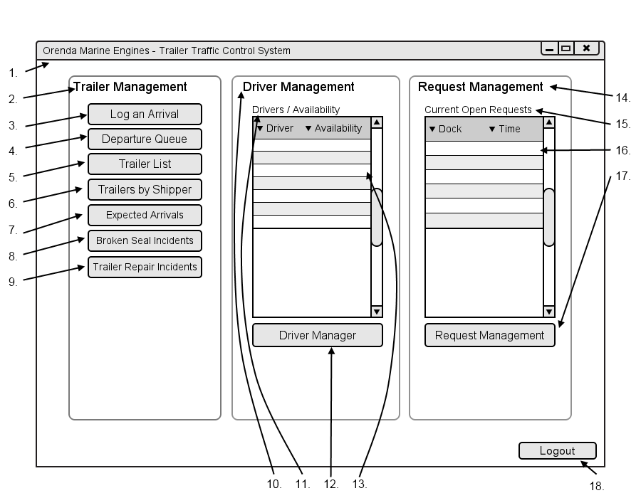

|  |  |  |  |
| --- | --- | --- | --- |
| # | Type | Text | Functions/Notes |
| 1 | Windows | Orenda Marine Engines – Trailer Traffic Control System | 800x600 |
| 2 | Label | Trailer Management |  |
| 3 | Button | Log An Arrival | Displays the Bill of Lading Dialog |
| 4 | Button | Departure Queue | Displays the Departure Queue Dialog |
| 5 | Button | Trailer List | Displays the Trailer List Screen |
| 6 | Button | Trailer By Shipper | Displays the Trailer By Shipper Filter Dialog |
| 7 | Button | Expected Arrivals | Displays the Expected Arrivals Screen |
| 8 | Button | Broken Seal Incidents | Displays the Broken Seal Incidents Screen |
| 9 | Button | Trailer Repair Incidents | Displays the Trailer Repair Incidents Screen |
| 10 | Label | Driver Management |  |
| 11 | Label | Drivers/Availability |  |
| 12 | DataGrid |  | Fields : Driver Name, Current Availability  This displays a list of all current drivers and their current status : Off Duty, Available, On Task |
| 13 | Button | Driver Manager | Displays the Driver Manager Screen |
| 14 | Label | Request Management |  |
| 15 | Label | Current Open Requests |  |
| 16 | DataGrid |  | Fields : Dock, Time  This displays a list of all requests that need the dispatchers’ attention.  They are sorted by Time from soonest to latest. Plant are highlighted light green, warehouse are highlighted light blue.  Requests with an issue are placed at the top highlighted red. |
| 17 | Button | Request Management | Displays the Request Management Screen |
| 18 | Button | Logout | Logs the Dispatcher out of the system |

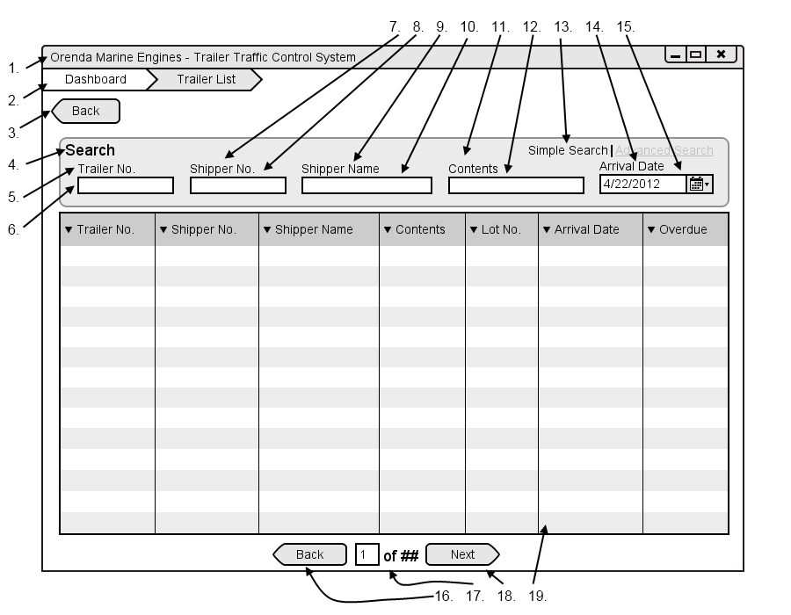

|  |  |  |  |
| --- | --- | --- | --- |
| # | Type | Text | Functions/Notes |
| 1 | Windows | Orenda Marine Engines – Trailer Traffic Control System | 800x600 |
| 2 | Breadcrumb |  | A list of all pages and subpages of the currently accessed page |
| 3 | Button | Back | Return to the Dispatcher Dashboard |
| 4 | Label | Search |  |
| 5 | Label | Trailer No. |  |
| 6 | Text Box |  | Trailer Number textbox, when it is filled in and taken from focus it filters the Datagrid |
| 7 | Label | Shipper No. |  |
| 8 | Text Box |  | Shipper No textbox, when it is filled in and removed from focus it filters the Datagrid |
| 9 | Label | Shipper Name |  |
| 10 | Text Box |  | Shipper Name textbox, when it is filled in and removed from focus it filters the Datagrid |
| 11 | Label | Contents |  |
| 12 | Text Box |  | Contents Textbox, when it is filled in and removed from focus it filters the Datagrid |
| 13 | Link | Simple Search | Advanced Search | Clicking this opens the Advanced Search options |
| 14 | Label | Arrival Date |  |
| 15 | Date Picker |  | Arrival Date Picker, when it is filled in and removed from focus it filters the Datagrid |
| 16 | Button | Back | Move back one list of trailers, only visible if there are enough results to require multiple pages. |
| 17 | Label | ## of ## | Display the number based on the current page and the total pages |
| 18 | Button | Next | Move forward one list of trailers, only visible if there are enough results to require multiple pages. |
| 19 | Datagrid |  | Fields: Trailer No., Shipper No., Shipper Name, Contents, Lot No., Arrival Date, Overdue  A list of all trailers that are current on the Orenda Properties |

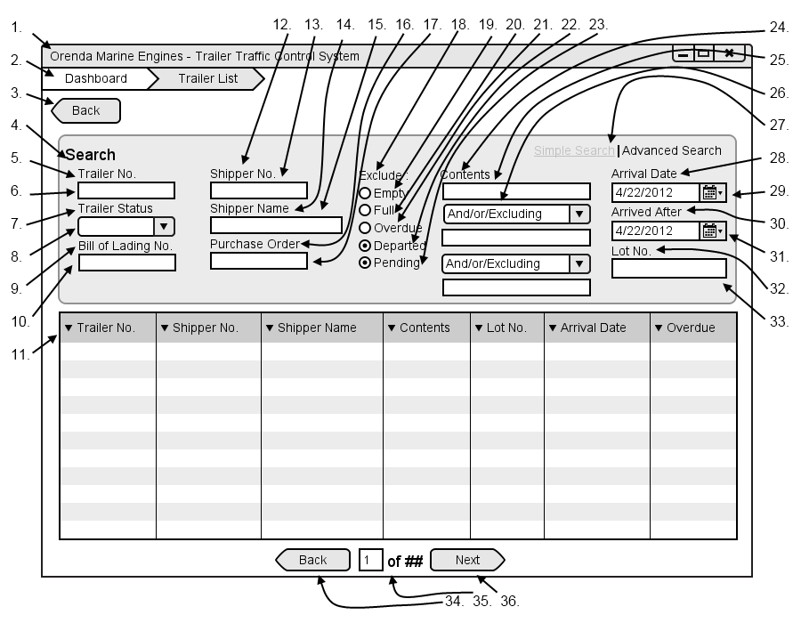

|  |  |  |  |
| --- | --- | --- | --- |
| # | Type | Text | Functions/Notes |
| 1 | Windows | Orenda Marine Engines – Trailer Traffic Control System | 800x600 |
| 2 | Breadcrumb |  | A list of all pages and subpages of the currently accessed page |
| 3 | Button | Back | Return to the Dispatcher Dashboard |
| 4 | Label | Search |  |
| 5 | Label | Trailer No. |  |
| 6 | Text Box |  | Trailer Number textbox, when it is filled in and taken from focus it filters the Datagrid |
| 7 | Label | Trailer Status |  |
| 8 | Selection Box |  | A list of all trailer status, once this is changed it automatically filters the Datagrid |
| 9 | Label | Trailer No. |  |
| 10 | Text Box |  | Bill of Lading textbox, when it is filled in and taken from focus it filters the Datagrid |
| 11 | Datagrid |  | Fields: Trailer No., Shipper No., Shipper Name, Contents, Lot No., Arrival Date, Overdue  A list of all trailers that are current on the Orenda Properties |
| 12 | Label | Shipper No. |  |
| 13 | Text Box |  | Shipper No textbox, when it is filled in and removed from focus it filters the Datagrid |
| 14 | Label | Shipper Name |  |
| 15 | Text Box |  | Shipper Name textbox, when it is filled in and removed from focus it filters the Datagrid |
| 16 | Label | Purchase Order |  |
| 17 | Text Box |  | Purchase Order textbox, when it is filled in and removed from focus it filters the Datagrid |
| 18 | Label | Exclude: |  |
| 19 | Radio Button | Empty | Filters out any empty trailers when selected |
| 20 | Radio Button | Full | Filters out any full trailers when selected |
| 21 | Radio Button | Overdue | Filters out any overdue trailers when selected |
| 22 | Radio Button | Departed | Filters out any departed trailers when selected |
| 23 | Radio Button | Pending | Filters out any pending trailers when selected |
| 24 | Label | Contents |  |
| 25 | Text Box |  | Contents textbox, when it is filled in and taken from focus it filters the Datagrid |
| 26 | Selection Box |  | And/or/Excluding |
| 27 | Link | Simple Search | Advanced Search | Clicking this opens the Simple Search options |
| 28 | Label | Arrival Date |  |
| 29 | Date Picker |  | Arrival Date Picker, when it is filled in and removed from focus it filters the Datagrid |
| 30 | Label | Arrived After |  |
| 31 | Date Picker |  | Arrived After Picker, when it is filled in and removed from focus it filters the Datagrid |
| 32 | Label | Lot No. |  |
| 33 | Text Box |  | Lot No. textbox, when it is filled in and taken from focus it filters the Datagrid |
| 34 | Button | Back | Move back one list of trailers, only visible if there are enough results to require multiple pages. |
| 35 | Label | ## of ## | Display the number based on the current page and the total pages |
| 36 | Button | Next | Move forward one list of trailers, only visible if there are enough results to require multiple pages. |

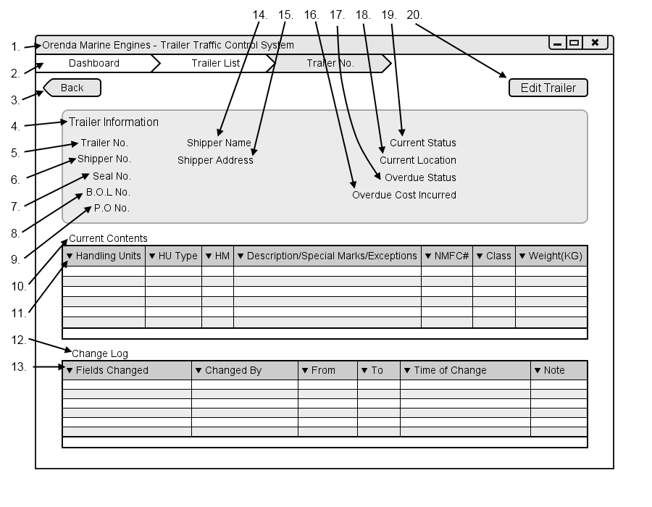

|  |  |  |  |
| --- | --- | --- | --- |
| # | Type | Text | Functions/Notes |
| 1 | Windows | Orenda Marine Engines – Trailer Traffic Control System | 800x600 |
| 2 | Breadcrumb |  | A list of all pages and subpages of the currently accessed page |
| 3 | Button | Back | Return to the Dispatcher Dashboard |
| 4 | Label | Trailer Information |  |
| 5 | Label | Trailer No. | Followed By the trailer number |
| 6 | Label | Shipper No. | Followed By the shipper number |
| 7 | Label | Seal No. | Followed By the seal number |
| 8 | Label | B.O.L No. | Followed By the B.O.L number |
| 9 | Label | P.O No. | Followed By the P.O Number |
| 10 | Label | Current Contents |  |
| 11 | Datagrid |  | Fields: Handleing, HU Type, HM, Description/Special Marks/Exceptions,NMFC#,Class,Weights(KG)  A list of all contents within the selected trailer |
| 12 | Label | Change Log |  |
| 13 | Datagrid |  | Fields: Fields Changes, Changed By, From, To, Time of Change, Note  A list of all changes made to the trailer record from being entered into the system to departure |
| 14 | Label | Shipper Name | Followed By the Shipper Name |
| 15 | Label | Shipper Address | Followed By the Shipper Address |
| 16 | Label | Current Status | Followed By the Current Status |
| 17 | Label | Current Location | Followed By the Current Location |
| 18 | Label | Overdue Status | Followed By the Overdue Status |
| 19 | Label | Overdue Inccurred Costs | Followed By the Overdue Inccurred Costs |
| 20 | Button | Edit Trailer | Opens the edit trailer screen |

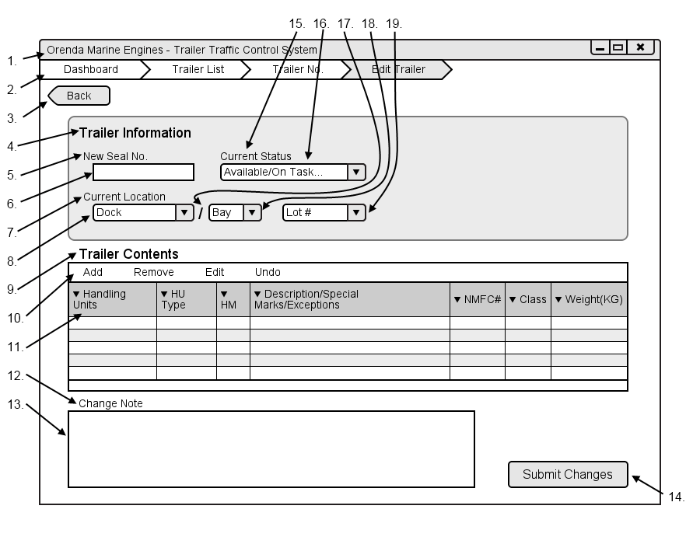

|  |  |  |  |
| --- | --- | --- | --- |
| # | Type | Text | Functions/Notes |
| 1 | Windows | Orenda Marine Engines – Trailer Traffic Control System | 800x600 |
| 2 | Breadcrumb |  | A list of all pages and subpages of the currently accessed page |
| 3 | Button | Back | Return to the Trailer List |
| 4 | Label | Trailer Information |  |
| 5 | Label | New Seal No. |  |
| 6 | Textbox |  | New Seal No. Textbox |
| 7 | Label | Current Location |  |
| 8 | Selection Box |  | A list of all locations in the yard that the trailer can be |
| 9 | Label | Trailer Contents |  |
| 10 | GridMenu |  | Options : Add, Remove, Edit, undo  A menu used to edit the inventory DataGrid |
| 11 | Datagrid |  | Fields: Handleing, HU Type, HM, Description/Special Marks/Exceptions,NMFC#,Class,Weights(KG)  A list of all contents within the selected trailer |
| 12 | Label | Change Note |  |
| 13 | Textbox |  | The change note text box |
| 14 | Button | Submit Changes | Submits the changes that were made, updating the record and adding an item to the change log of the trailer |
| 15 | Label | Current Status |  |
| 16 | Selection Box |  | A list of all available statuses to be selected from |
| 17 | Label | / |  |
| 18 | SelectionBox |  | A list of all bays available at the selected dock if applicable |
| 19 | Textbox |  | Lot number text box |

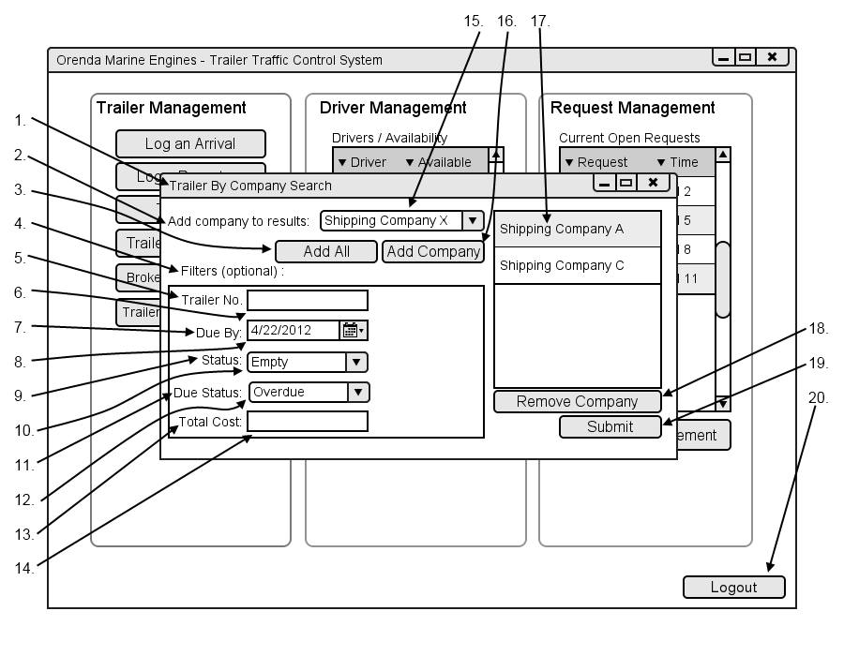

|  |  |  |  |
| --- | --- | --- | --- |
| # | Type | Text | Functions/Notes |
| 1 | Container | Trailer Company Search |  |
| 2 | Label | Add company to results: |  |
| 3 | Button | Add All | Adds all companies to the datagrid |
| 4 | Label | Filters (optional) : |  |
| 5 | Label | Trailer No. |  |
| 6 | Text Box |  | Trailer number text box |
| 7 | Label | Due By |  |
| 8 | Date picker |  | Due By date picker |
| 9 | Label | Status |  |
| 10 | Selection Box |  | Status selection box is populated with all trailer statuses |
| 11 | Label | Due Status |  |
| 12 | Selection Box |  | A list of all overdue statuses |
| 13 | Label | Total Cost |  |
| 14 | Textbox |  | Total Cost Textbox |
| 15 | Selection box |  | List of all available shipping companies |
| 16 | Button | Add Company | Adds the selected company to the list |
| 17 | DataList |  | A list of all companies added |
| 18 | Button | Remove Company | Removes the selected company from the list |
| 19 | Submit |  | Submits the filters and displays the Trailer by company screen based on the selected filters |

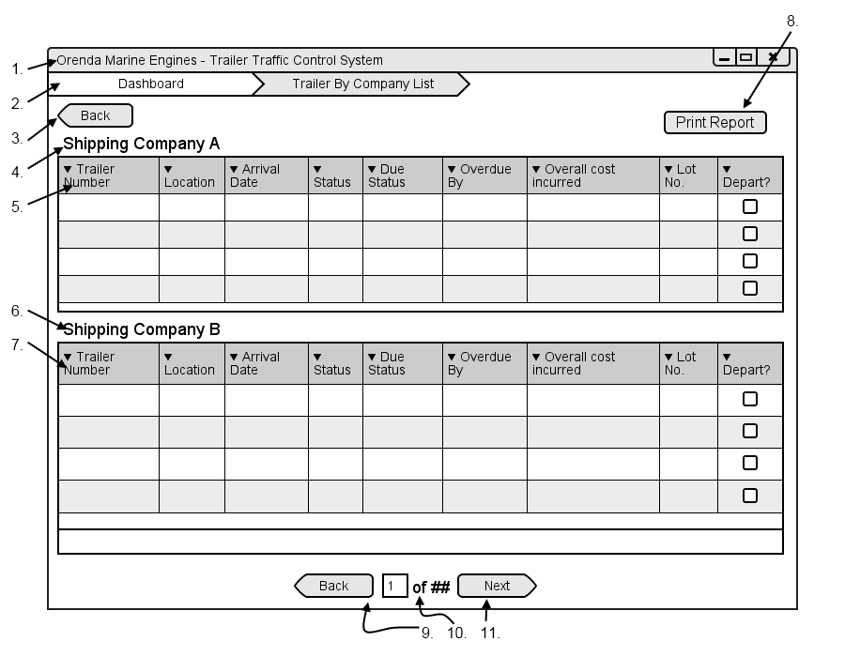

|  |  |  |  |
| --- | --- | --- | --- |
| # | Type | Text | Functions/Notes |
| 1 | Windows | Orenda Marine Engines – Trailer Traffic Control System | 800x600 |
| 2 | Breadcrumb |  | A list of all pages and subpages of the currently accessed page |
| 3 | Button | Back | Return to the Dispatcher Dashboard |
| 4 | Label | Shipping Company Name |  |
| 5 | DataGrid |  | Fields : Trailer Number, Location, Arrival Date, Status, Due status, Overdue By, Overall cost incurred, lot no., depart checkbox  A list of all trailers on the property sorted by trucking company. |
| 6 | Label | Shipping Company Name |  |
| 7 | DataGrid |  | Fields : Trailer Number, Location, Arrival Date, Status, Due status, Overdue By, Overall cost incurred, lot no., depart checkbox  A list of all trailers on the property sorted by trucking company. |
| 8 | Button | Print Report | Bring up the print report dialog |
| 9 | Button | Back | Move back one list of trailers, only visible if there are enough results to require multiple pages. |
| 10 | Label | ## of ## | Display the number based on the current page and the total pages |
| 11 | Button | Next | Move forward one list of trailers, only visible if there are enough results to require multiple pages. |

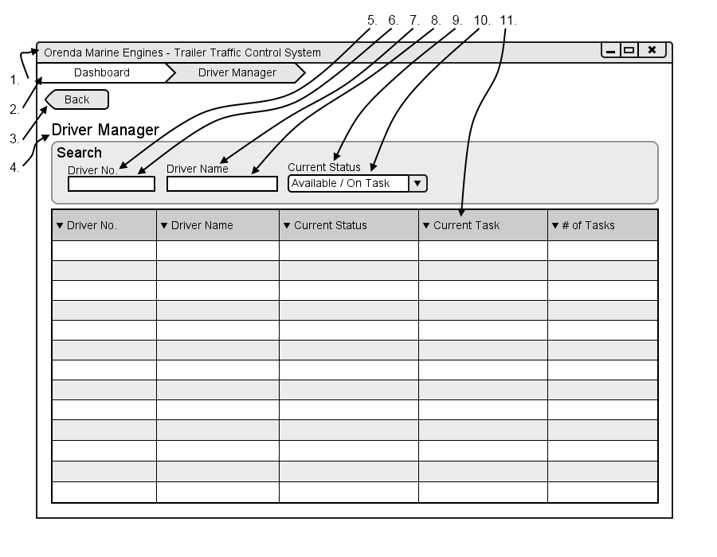

|  |  |  |  |
| --- | --- | --- | --- |
| # | Type | Text | Functions/Notes |
| 1 | Windows | Orenda Marine Engines – Trailer Traffic Control System | 800x600 |
| 2 | Breadcrumb |  | A list of all pages and subpages of the currently accessed page |
| 3 | Button | Back | Return to the Dispatcher Dashboard |
| 4 | Label | Driver Manager |  |
| 5 | Label | Driver No |  |
| 6 | Textbox |  | Driver Number Textbox |
| 7 | Label | Driver Name |  |
| 8 | Textbox |  | Driver name Textbox |
| 9 | Label | Current Status |  |
| 10 | Selection box |  | List of driver statuses |
| 11 | Datagrid |  | Fields: Driver No, Driver name, Current Status, Current Task, # of Tasks.  A list of all current drivers on Orendas property. By clicking on the number of tasks it displays a list of all of the drivers tasks in a dialog box |

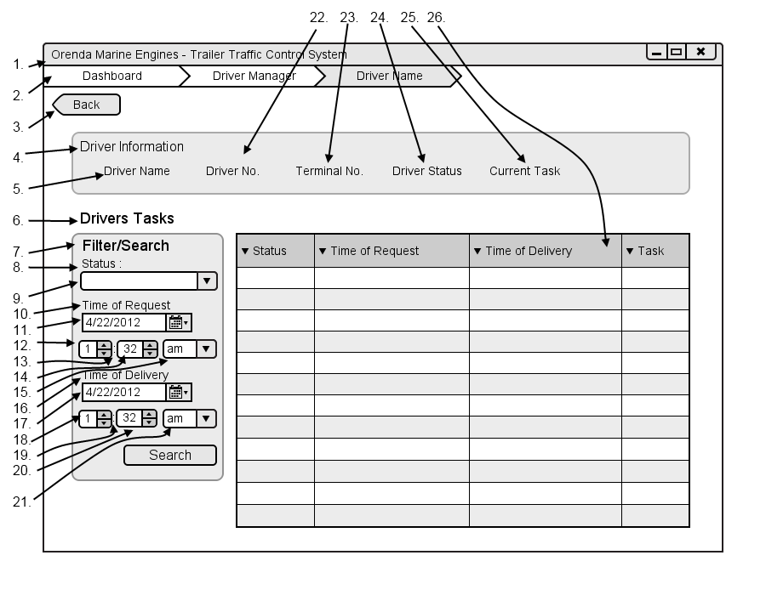

|  |  |  |  |
| --- | --- | --- | --- |
| # | Type | Text | Functions/Notes |
| 1 | Windows | Orenda Marine Engines – Trailer Traffic Control System | 800x600 |
| 2 | Breadcrumb |  | A list of all pages and subpages of the currently accessed page |
| 3 | Button | Back | Return to the Dispatcher Dashboard |
| 4 | Label | Driver Information |  |
| 5 | Label | Driver Name | Followed by the drivers name |
| 6 | Label | Drivers Tasks |  |
| 7 | Label | Filter/Search |  |
| 8 | Label | Status |  |
| 9 | Selection box |  | List of all task statuses |
| 10 | Label | Time of request |  |
| 11 | Date Picker |  | Time of request date picker |
| 12 | Selection Box |  | Numbers one through 12 |
| 13 | Label | : |  |
| 14 | Selection Box |  | Numbers 1 through 59 |
| 15 | Selection box |  | Am / pm |
| 16 | Label | Time of delivery |  |
| 17 | Date Picker |  | Time of delivery date picker |
| 18 | Selection Box |  | Numbers one through 12 |
| 19 | Label | : |  |
| 20 | Selection Box |  | Numbers 1 through 59 |
| 21 | Selection box |  | Am / pm |
| 22 | Label | Driver No. | Followed by the drivers Number |
| 23 | Label | Terminal No | Followed by the terminal number |
| 24 | Label | Driver Status | Followed by the status |
| 25 | Label | Current Task | Followed By Current Task |
| 26 | DataGrid |  | Fields: Status, Time of Request, Time of Delivery, Task |

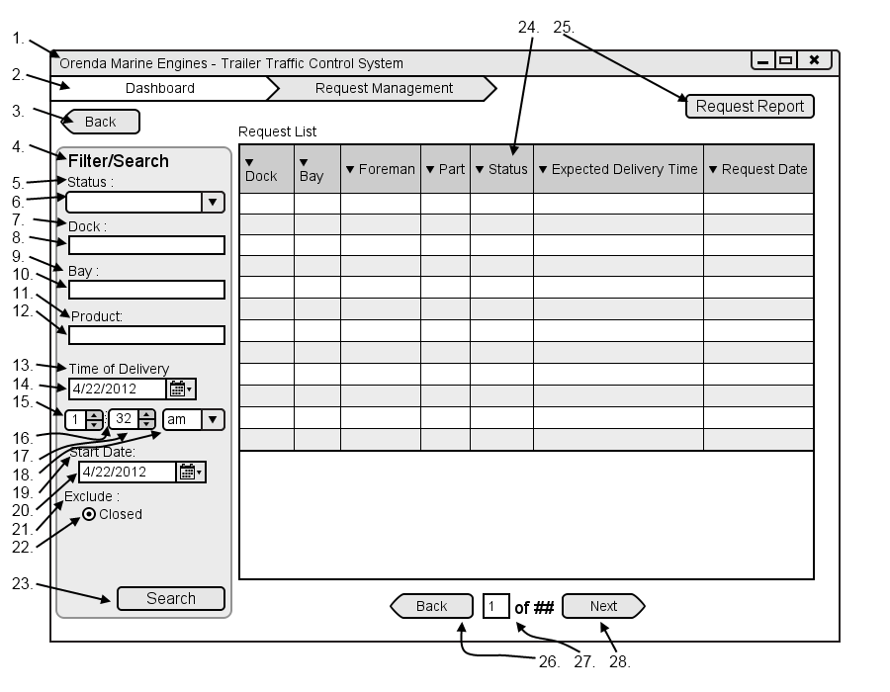

|  |  |  |  |
| --- | --- | --- | --- |
| # | Type | Text | Functions/Notes |
| 1 | Windows | Orenda Marine Engines – Trailer Traffic Control System | 800x600 |
| 2 | Breadcrumb |  | A list of all pages and subpages of the currently accessed page |
| 3 | Button | Back | Return to the Dispatcher Dashboard |
| 4 | Label | Filter/Search |  |
| 5 | Label | Status |  |
| 6 | Selection box |  | List of all task statuses |
| 7 | Label | Dock: |  |
| 8 | Textbox |  | Dock textbox |
| 9 | Label | Bay: |  |
| 10 | Textbox |  | Bay textbox |
| 11 | Label | Product: |  |
| 12 | Label | Time of delivery |  |
| 13 | Date Picker |  | Time of delivery date picker |
| 14 | Selection Box |  | Numbers one through 12 |
| 15 | Label | : |  |
| 16 | Selection Box |  | Numbers 1 through 59 |
| 17 | Selection box |  | Am / pm |
| 18 | Label | Start Date: |  |
| 19 | Date Picker |  | Start Dare Picker |
| 20 | Label | Exclude |  |
| 21 | Radio Button | Closed | Removes all closed requests if checked |
| 22 | DataGrid |  | Fields: Dock, Bay, Foreman, Part, Status, Expected Deliver Time, Request Date  A list of all requests that match the currently selected search criteria |
| 23 | Button | Request Report | Displays the print report dialog |
| 24 | Button | Back | Move back one list of trailers, only visible if there are enough results to require multiple pages. |
| 25 | Label | ## of ## | Display the number based on the current page and the total pages |
| 26 | Button | Next | Move forward one list of trailers, only visible if there are enough results to require multiple pages. |

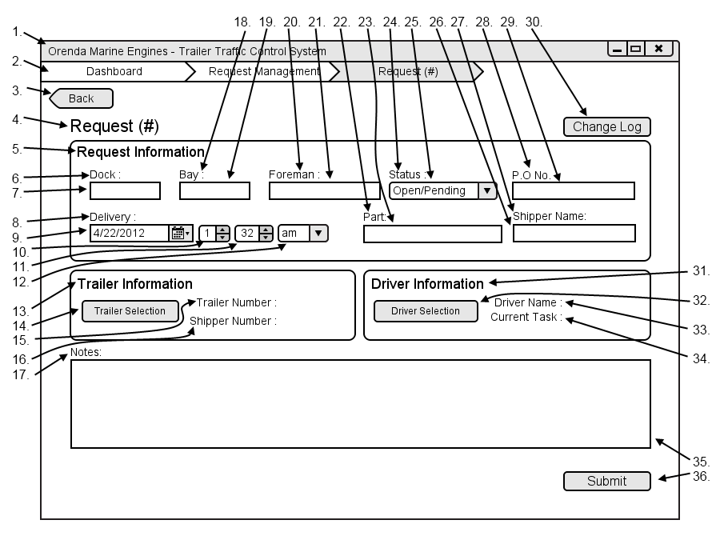

|  |  |  |  |
| --- | --- | --- | --- |
| # | Type | Text | Functions/Notes |
| 1 | Windows | Orenda Marine Engines – Trailer Traffic Control System | 800x600 |
| 2 | Breadcrumb |  | A list of all pages and subpages of the currently accessed page |
| 3 | Button | Back | Return to the Request Management |
| 4 | Label | Request # | # is the Unique request ID |
| 5 | Label | Request Information |  |
| 6 | Label | Dock: |  |
| 7 | Textbox |  | Dock textbox |
| 8 | Label | Time of delivery |  |
| 9 | Date Picker |  | Time of delivery date picker |
| 10 | Selection Box |  | Numbers one through 12 |
| 11 | Selection Box |  | Numbers 1 through 59 |
| 12 | Selection box |  | Am / pm |
| 13 | Label | Trailer Information |  |
| 14 | Button | Trailer Selection | Opens the Trailer list in advanced view with all information fron the request already entered |
| 15 | Label | Trailer No. | Followed By the Trailer No. |
| 16 | Label | Shipper Name | Followed By the Shipper Name |
| 17 | Label | Notes: |  |
| 18 | Label | Bay: |  |
| 19 | Textbox |  | Bay textbox |
| 20 | Label | Foreman: |  |
| 21 | Textbox |  | Foreman textbox |
| 22 | Label | Part: |  |
| 23 | Textbox |  | Part textbox |
| 24 | Label | Status |  |
| 25 | Selection box |  | List of all task statuses |
| 26 | Label | Shipping Name: |  |
| 27 | Textbox |  | Shipping Name textbox |
| 28 | Label | P.O No. |  |
| 29 | Textbox |  | P.O No. textbox |
| 30 | Button | Change Log | Opens the Change log for the request |
| 31 | Label | Driver Information |  |
| 32 | Button | Driver Selection | Opens the Driver list in advanced view with all information from the request already entered |
| 33 | Label | Driver Name : | Followed By the Driver Name : |
| 34 | Label | Current Task | Followed By the Current Task |
| 35 | Textbox |  | Note for the change to the request |
| 36 | Button | Submit | Submits the changes to the request and sends in to the appropriate sources |

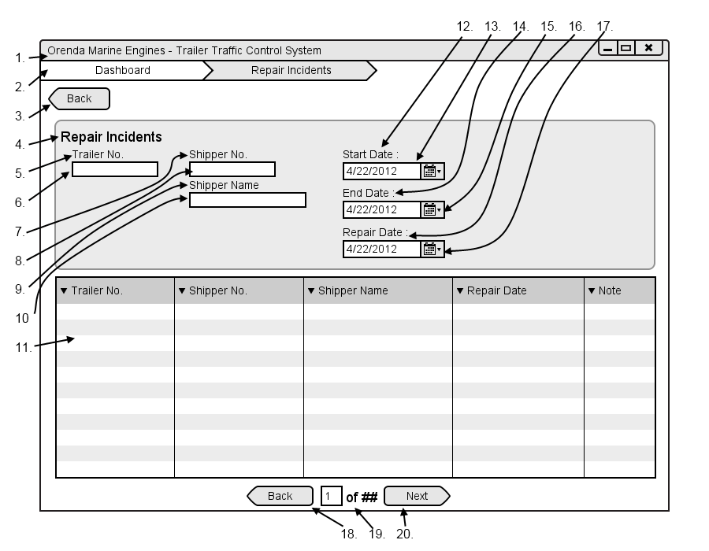

|  |  |  |  |
| --- | --- | --- | --- |
| # | Type | Text | Functions/Notes |
| 1 | Windows | Orenda Marine Engines – Trailer Traffic Control System | 800x600 |
| 2 | Breadcrumb |  | A list of all pages and subpages of the currently accessed page |
| 3 | Button | Back | Return to the Dispatchers Dashboard |
| 4 | Label | Repair Incidents |  |
| 5 | Label | Trailer No. |  |
| 6 | Text Box |  | Trailer Number textbox, when it is filled in and taken from focus it filters the Datagrid |
| 7 | Label | Shipper No. |  |
| 8 | Text Box |  | Shipper No textbox, when it is filled in and removed from focus it filters the Datagrid |
| 9 | Label | Shipper Name |  |
| 10 | Text Box |  | Shipper Name textbox, when it is filled in and removed from focus it filters the Datagrid |
| 11 | Datagrid |  | Fields: Trailer No., Shipper No., Shipper Name, Repair Date, Note  A list of all trailers that have needed repair within the specified filter dates |
| 12 | Label | Start Date: |  |
| 13 | Date Picker |  | Start Date picker |
| 14 | Label | End Date: |  |
| 15 | Date Picker |  | End Date picker |
| 16 | Label | Repair Date: |  |
| 17 | Date Picker |  | Repair date picker |
| 18 | Button | Back | Move back one list of trailers, only visible if there are enough results to require multiple pages. |
| 19 | Label | ## of ## | Display the number based on the current page and the total pages |
| 20 | Button | Next | Move forward one list of trailers, only visible if there are enough results to require multiple pages. |

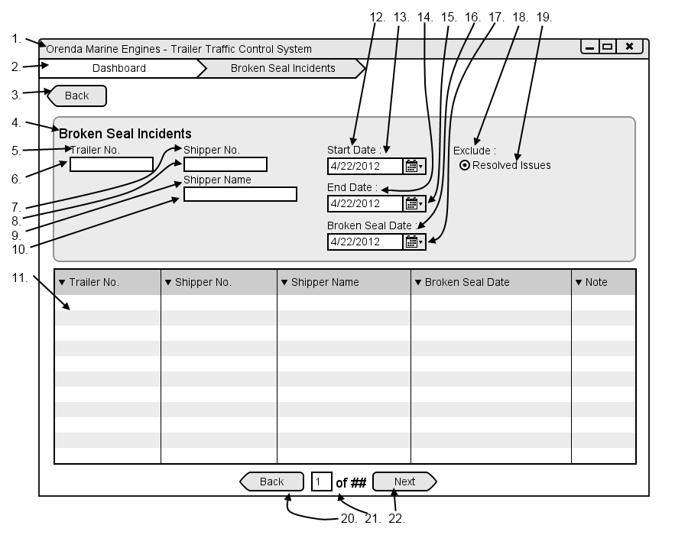

|  |  |  |  |
| --- | --- | --- | --- |
| # | Type | Text | Functions/Notes |
| 1 | Windows | Orenda Marine Engines – Trailer Traffic Control System | 800x600 |
| 2 | Breadcrumb |  | A list of all pages and subpages of the currently accessed page |
| 3 | Button | Back | Return to the Dispatchers Dashboard |
| 4 | Label | Broken Seal Incidents |  |
| 5 | Label | Trailer No. |  |
| 6 | Text Box |  | Trailer Number textbox, when it is filled in and taken from focus it filters the Datagrid |
| 7 | Label | Shipper No. |  |
| 8 | Text Box |  | Shipper No textbox, when it is filled in and removed from focus it filters the Datagrid |
| 9 | Label | Shipper Name |  |
| 10 | Text Box |  | Shipper Name textbox, when it is filled in and removed from focus it filters the Datagrid |
| 11 | Datagrid |  | Fields: Trailer No., Shipper No., Shipper Name, Repair Date, Note  A list of all trailers that have been found to have a broken seal within the specified filter dates |
| 12 | Label | Start Date: |  |
| 13 | Date Picker |  | Start Date picker |
| 14 | Label | End Date: |  |
| 15 | Date Picker |  | End Date picker |
| 16 | Label | Repair Date: |  |
| 17 | Date Picker |  | Repair date picker |
| 18 | Label | Exclude: |  |
| 19 | Radio | Resolved Issues | When checked broken seal incidents that have been resolved are nor displayed |
| 20 | Button | Back | Move back one list of trailers, only visible if there are enough results to require multiple pages. |
| 21 | Label | ## of ## | Display the number based on the current page and the total pages |
| 22 | Button | Next | Move forward one list of trailers, only visible if there are enough results to require multiple pages. |

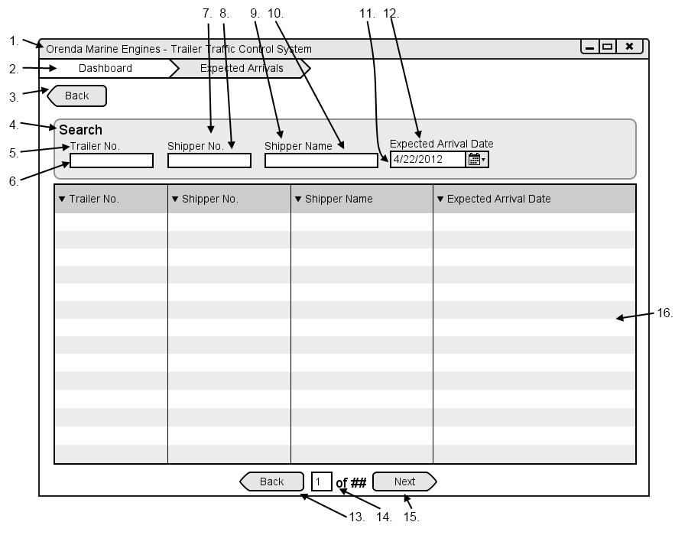

|  |  |  |  |
| --- | --- | --- | --- |
| # | Type | Text | Functions/Notes |
| 1 | Windows | Orenda Marine Engines – Trailer Traffic Control System | 800x600 |
| 2 | Breadcrumb |  | A list of all pages and subpages of the currently accessed page |
| 3 | Button | Back | Return to the Dispatchers Dashboard |
| 4 | Label | Search |  |
| 5 | Label | Trailer No. |  |
| 6 | Text Box |  | Trailer Number textbox, when it is filled in and taken from focus it filters the Datagrid |
| 7 | Label | Shipper No. |  |
| 8 | Text Box |  | Shipper No textbox, when it is filled in and removed from focus it filters the Datagrid |
| 9 | Label | Shipper Name |  |
| 10 | Text Box |  | Shipper Name textbox, when it is filled in and removed from focus it filters the Datagrid |
| 11 | Label | Expected Arrival Date |  |
| 12 | Date Picker |  | Start Date picker |
| 13 | Button | Back | Move back one list of trailers, only visible if there are enough results to require multiple pages. |
| 14 | Label | ## of ## | Display the number based on the current page and the total pages |
| 15 | Button | Next | Move forward one list of trailers, only visible if there are enough results to require multiple pages. |
| 16 | Datagrid |  | Fields: Trailer No., Shipper No., Shipper Name, Expected Arrival Date  A list of all trailers expected to arrive or in pending status |

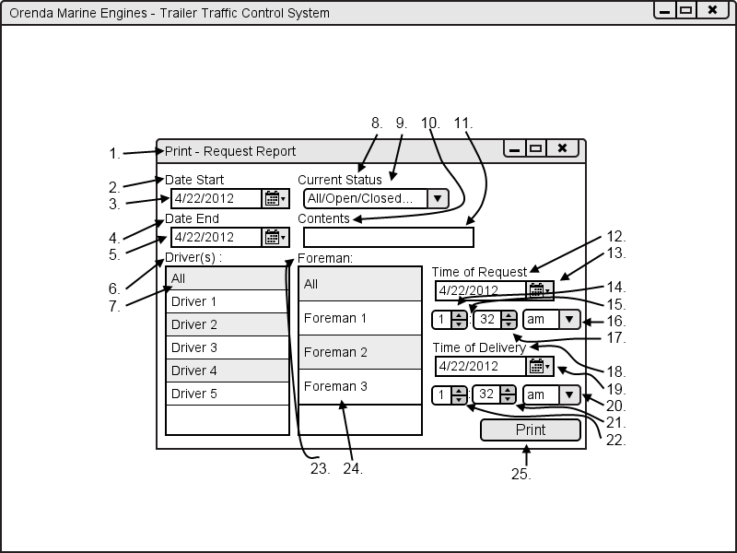

|  |  |  |  |
| --- | --- | --- | --- |
| # | Type | Text | Functions/Notes |
| 1 | Windows | Print - Report Name |  |
| 2 | Label | Start Date: |  |
| 3 | Date Picker |  | Start Date picker |
| 4 | Label | End Date: |  |
| 5 | Date Picker |  | End Date picker |
| 6 | Labels | Driver(s) : |  |
| 7 | DataList |  | List of all drivers in the system, more than one can be selected |
| 8 | Labels | Current Status |  |
| 9 | Selection box |  | List of all requests statuses |
| 10 | Labels | Contents |  |
| 11 | Textbox |  | Contents text box |
| 12 | Label | Time of request |  |
| 13 | Date Picker |  | Time of request date picker |
| 14 | Selection Box |  | Numbers one through 12 |
| 15 | Label | : |  |
| 16 | Selection box |  | Am / pm |
| 17 | Selection Box |  | Numbers 1 through 59 |
| 18 | Label | Time of delivery |  |
| 19 | Date Picker |  | Time of delivery date picker |
| 20 | Selection box |  | Am / pm |
| 21 | Selection Box |  | Numbers 1 through 59 |
| 22 | Selection Box |  | Numbers one through 12 |
| 23 | Label | Foreman: |  |
| 24 | DataList |  | A list of all foremen in the system. More than on can be selected |
| 25 | Button | Print | Print report based off information selected |

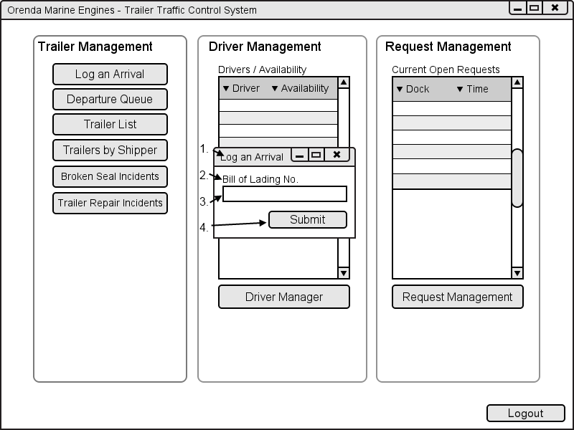

|  |  |  |  |
| --- | --- | --- | --- |
| # | Type | Text | Functions/Notes |
| 1 | Windows | Log an Arrival |  |
| 2 | Label | Bill of Lading No. |  |
| 3 | Text box |  | B.O.L text box |
| 4 | Button | Submit | Brings the dispatcher to the trailer screen of the trailer associated with the Bill of Lading entered |

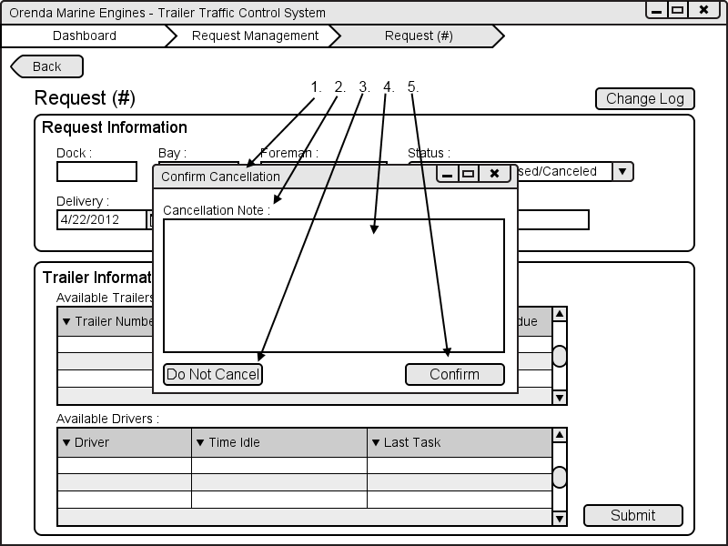

|  |  |  |  |
| --- | --- | --- | --- |
| # | Type | Text | Functions/Notes |
| 1 | Windows | Cancel Confirmation |  |
| 2 | Label | Cancellation Note : |  |
| 3 | Button | Do Not Cancel | Returns to the request screen with no changes |
| 4 | Text box |  | Cancellation Note Text Box |
| 5 | Button | Confirm | Returns to the request screen with the status changes to canceled |